Coonamble Public School

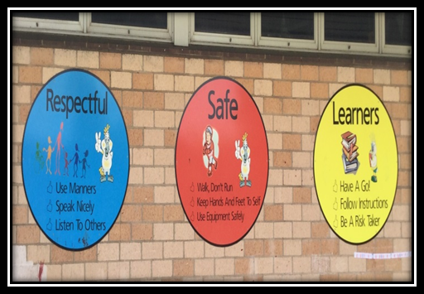
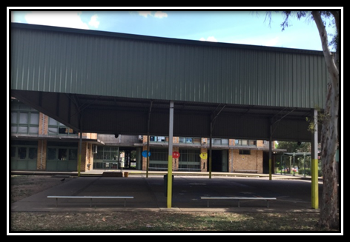

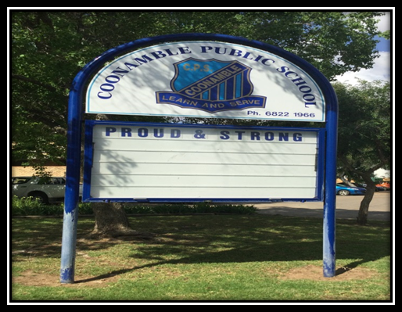
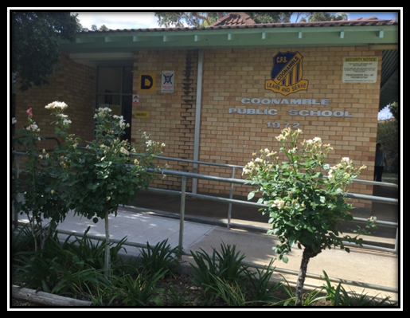

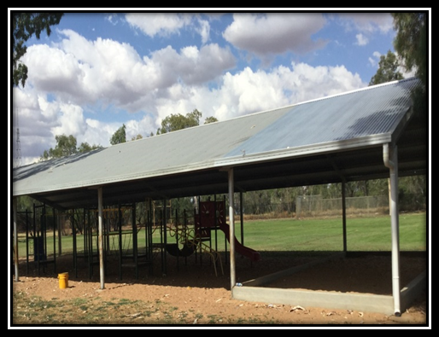
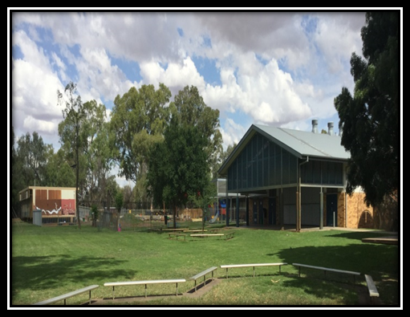

Information Booklet

Notes page:

Core rules for students in NSW government schools

Students in NSW government schools are provided with a high quality education so that they may learn to the best of their ability and become self-disciplined, tolerant, enterprising and contributing members of the school and community.

Core rules for student behaviour have been developed to establish consistent expectations in all government schools in support of these aims.

These rules are based on our core values of integrity, excellence, respect, responsibility, cooperation, participation, care, fairness and democracy.

The critical role of parents and caregivers is recognised as the primary influence on each child’s character and behaviour and as essential partners in supporting the core rules and the successful education of their children.

The Department is committed to supporting principals and school staff in the implementation of these rules through statewide policies and programs, together with regional support staff, professional learning and alternative provisions, in order to promote the highest standards of behaviour and learning in our schools.

The core rules

All students in NSW are expected to:

- Attend every school day, unless they are legally excused, and be in class on time and prepared to learn.

- Maintain a neat appearance, including adhering to the requirements of the school’s uniform and dress code policy.

- Behave safely, considerately and responsibly, including when travelling to and from school.

- Show respect at all times for teachers, other school staff and helpers, including following class rules, speaking courteously and cooperating with instructions and learning activities.

- Treat one another with dignity and respect.

- Care for property belonging to themselves, the school and others.

Behaviour that infringes on the safety of others, such as harassment, bullying and illegal or anti-social behaviour of any kind, will not be tolerated.
SCHOOL CREED

This is our school
Let peace dwell here,
Let the rooms be full of contentment, Let love abide here.
Love of God, love of one another, and love of life itself.
Let us remember,
That as many hands make a house, and many hearts make a school.

NATIONAL ANTHEM

Advance Australia Fair
Australians all let us rejoice for we are young and free
We’ve golden soil and wealth for toil, our home is girt by sea
Our land abounds in nature’s gifts of beauty rich and rare,
In history’s page let every stage Advance Australia fair,
In joyful strains then let us sing Advance Australia fair.
Beneath our radiant Southern Cross We’ll toil with hearts and hands,
To make this Commonwealth of ours Renowned of all the lands,
For those who’ve come across the seas we’ve boundless plains to share, with courage let us all combine
To Advance Australia fair.
In joyful strains then let us sing, Advance Australia fair.

Coonamble Public School
P.O. Box 195 COONAMBLE NSW 2829
Phone – 6822 1966
Fax – 6822 1294
Email - coonamble-p.school@det.nsw.edu.au

CHANGE OF ADDRESS OR TELEPHONE NUMBER

It is important that the school has current contact details for all families. Please notify the school should you change your name, address or telephone number so that we can keep school records in order. This also means that we can contact you easily if the need arises.

ILLNESS OR ACCIDENT

In the event of illness or accident to your child, we will try to contact you or another person nominated by you if you are unavailable. Should we not be able to contact you and if medical help is urgently needed, we will seek this from the hospital, the ambulance service or doctor nominated by you.

Parents, Carers and Community members are welcome at Coonamble Public School

The school welcomes your involvement in your child’s education at home and at school. Everyone benefits from your involvement. Children love to see the people that are important to them at school. The School benefits from the skills and knowledge parents, grandparents, carers and community members bring and parents get to make friends and feel more connected to their child’s education.

Get to know your child’s teacher
It is important to introduce yourself early in the first semester to your child’s teacher. You can ask your child’s teacher how they will communicate with you and the best way to communicate with them.

If you are worried about any aspect of your child’s education or behaviour talk to your child’s teacher as early as possible. Teachers will make themselves available but they may need you to make an appointment. You can make an appointment through the office. If you want to help in the classroom, ask the teacher how you could do this.

Join a school committee
Parents may have opportunities to be involved in school committees and work with school staff on common goals, such as developing policies on student welfare, school uniform, use of school funds and facilities. These opportunities would be promoted in the newsletter or on facebook.

Parents often also get involved in raising funds for the school. These activities are fun and funds help the school to provide enhanced learning opportunities for students. Check the school newsletter for meeting times.

Ideas for helping at school

Whatever your lifestyle, time commitments, level of English, skills or education there is a job for you at your child’s school.
Here are some ideas:
- Listening to children read
- Helping with excursions
- Coaching a school sport team
- Covering books in the library
- Working in the canteen
- Planting a school garden
- Sewing costumes for a performance
- Promoting school activities

PARENTS AND CITIZENS ASSOCIATION

The P&C meet on the second Tuesday of each month. Meetings commence 5.30pm and the venue will be the community room at the school. The P&C Association provides important resources for the school and contributes to ideas and suggestions for improvement. The meetings are very informal and everyone is welcome.

ABORIGINAL EDUCATION CONSULTATIVE GROUP

The NSW AECG Inc. is an Aboriginal community-based organisation made up of volunteer members who are involved in Local and Regional AECGs throughout NSW. The NSW AECG Inc. is recognised as the principal source of advice on behalf of Aboriginal communities on issues relating to education and training. The aims of the association are;
- To ensure that the functions and powers of members are facilitated with the premise that the most critically important part of the consultative process is the active involvement of Local AECG members and communities.
- To provide opportunities for Aboriginal people to be actively involved in all decision-making that is relevant to education and training through a collaborative consultative process.
- To empower members by providing appropriate and effective knowledge and skills to engage in the development of policies and programs that enhances the unique cultural identity of Aboriginal students and promotes pride in Aboriginality.

CONNECTED COMMUNITIES STATEMENT

Connected Communities is a strategy to address the educational and social aspirations of Aboriginal children and young people living in a number of complex and diverse communities in NSW.

The strategy positions schools as community hubs that will deliver a range of services from birth through school, to further training and employment.

Connected Communities schools work in partnership with Aboriginal Leaders in the local community to help improve education outcomes for young Aboriginal people.

The strategy has been informed by advice from the Aboriginal Education Consultative Group (AECG).

CONNECTED COMMUNITIES REFERENCE GROUP

The Connected Communities Strategy is committed to delivering services through strong local partnerships. A local school governance group made up of the local Aboriginal community, AECG, parent and teacher representation will be established in each school community to work with the Executive Principal to develop the planning for the Strategy in each school. A Reference Group has been established at Coonamble Public School to help drive educational opportunities for students.

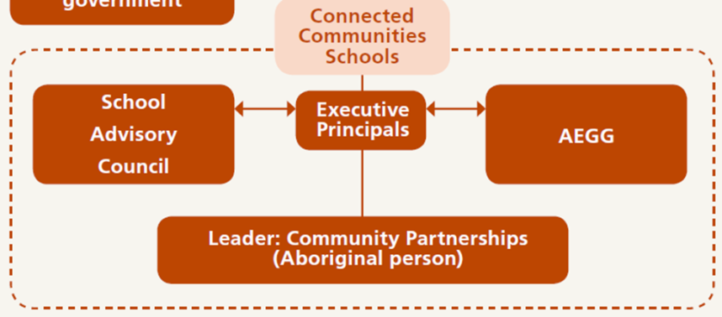

CANTEEN INFORMATION

The canteen is a member of Healthy Kids Association and operates under these guidelines. The canteen is open each school day from 8.30am until 12.30pm. It is run by a canteen manager and voluntary workers. Price lists are distributed at the beginning of the school year and then whenever necessary due to price increases. The canteen is always seeking volunteers who play an important role in the effective running of the canteen.
The canteen is a subsidiary of P&C.

ORDERING LUNCHES

When the students arrive at school they can go to the canteen and order their lunch. A bag is provided by the canteen and with the help of the canteen workers students write their order. Orders must be in by 9.30am.

ATTENDANCE

Going to school is important. Children are required to attend school once they turn six years of age.
If students miss as little as eight days in a school term, by the end of primary school they will have missed a year of education.
If students miss school they miss out on vital information, their learning routine is broken, they can lose confidence and miss out on building up friendships. All students are legally required to attend school every day including sports days unless they:
- are too sick to go to school,
- have been injured,
- have to go to a special religious ceremony,
- have an infectious illness or are involved in a serious family situation.

If your child is away from school, you are required to notify the school as soon as possible. This can be in the form of a note, phone call, email to the school or text message. Notification is required within 2 days of the child’s return to school. If there will be a prolonged absence, please notify the school immediately.
Please include the following:
- Child’s name and address
- Child’s class
- Dates and number of days your child was away
Explanation of the absence

If your child is late or needs to leave early:
If your child needs to leave school early to attend a doctor’s appointment for example, or arrives late they will need to sign in or out at the office.

Recording attendance
In primary school, attendance is usually recorded by your child’s teacher before the first lesson. Schools are required to inform parents promptly of any unexplained absences. Make sure the school has your current phone contact details so that they can get in touch with you if needed. Our school attendance officer will ring or visit to assist with regular attendance.

Home School Liaison Officers

Where attendance at school is a problem, a Home School Liaison Officer will work with families, schools and students to improve a child’s attendance.

SUPERVISION

The children are supervised at school between 8.30am and 3.00pm. Supervision is not provided outside these hours. We ask the support of parents in ensuring the safety of their children by not having the children arrive early at school or remain late.

SCHOOL TIMES

School opens 8.30am

School starts 9.00am

Lunch 11.30pm to 12.10pm

Recess 1.40pm to 2.15pm

Classes dismissed 3.00pm

Infants and Primary buses 3.00pm to 3.15pm

The first 10 minutes of Lunch is eating time and this takes place in the classrooms. The first 5 minutes of Recess is eating time and also takes place in the classroom.

BUSES

Country: Baradine, Billeroy, Carinda, Combara, Hollywood, Quambone, Tooraweenah, Warrington and Wooleybah.

Town: East (Yellow) and West (Blue).

Bus children are required to apply online to the Ministry of Transport when they start school. All infants’ children are allowed to travel on the town buses free once they have completed the online application. Primary children who live over 1.6 km from the school are eligible for free travel. Parents who convey children more than 1.6 km to meet a bus are eligible for a private car subsidy. Forms are available from the office. Children on buses are expected to behave in an appropriate manner.

UNIFORM

Children are expected to wear correct school uniform. The school canteen carries a large variety of uniforms for purchasing. Please call in to see the school uniform display at the school canteen.

CLOTHING POOL

A clothing pool operates from the school office to recycle uniforms no longer required by students and families. This operates from the donation of uniforms from the school community. Families experiencing difficulty in acquiring uniforms can apply for funding support through an application to the Principal

HATS

When children wear hats, they are protecting themselves from possible health risks from the sun. Coonamble is a member of the Sun Safe initiative and therefore has a “No School Hat, No Play” rule. The school will provide a hat on enrolment, and replacement hats may be purchased through the school office.

BICYCLES, SCOOTERS and RIPSTICKS

If children bring a bicycle, scooter or rip stick to school, they do so at their own risk and they must be parked in the allocated areas. There are racks at the front of the bus shed for children to place their bikes. Bicycles, scooters or ripsticks are not allowed to be ridden in the school grounds at any time.

HELMET REGULATIONS

Helmets are now required by Law for all children riding bikes, scooters and ripsticks. They are an important safety accessory. Helmets that are brought to school will be stored, during the day, in the classroom. Only children with helmets will be allowed to bring their bike, scooter or rip stick to school.

PARKING/ROAD SAFETY

Parking is allowed in the car park located at the eastern end of the school, across the road from the school and in front of the school in the times designated by the RMS signs. All people crossing the road should do so at the designated pedestrian crossing. A 40kph zone sign with flashing lights is in place outside the school and is patrolled regularly. Times enforced in these zones are 8am to 9.30am and 2.30pm to 4pm. These zones are to provide a safe environment for all students, parents, carers and community members.

KINDERGARTEN ENROLMENTS

Children may enrol in Kindergarten if they will have turned 5 years of age by the end of July. Proof of age such as a birth certificate is required on enrolment. In Term 4 each year, an orientation day is organised for all Kindergarten enrolments for the following year. Parents accompany the children on this day.

EXCURSIONS

Our school has an ongoing commitment to implementing excursions as part of the learning program. These are planned as part of the curriculum. Infants excursions are for a maximum of one day and parents receive information on these through notes sent home. Parents are quite often invited to attend and assist. Primary excursions are overnight with the senior primary ones being up to a full school week in duration. These are also designed to complement compulsory units of study.

LIBRARY

The library opens daily and children may borrow books on short term loan. The borrowing period is one week. Each class has a weekly library lesson. Each child is expected to have a material library bag big enough to fit a large picture book. You can assist your child to read by hearing him/her read to you as often as possible and by encouraging reading as a leisure time activity. Classes use the library for many and varied activities.

COMPUTERS/TECHNOLOGY

Our school endeavours to provide our students every opportunity to develop their knowledge and understanding of information and communication technologies. The school is well equipped with the latest teaching resources and technology. We have outstanding computer and technology facilities with computers and internet access in each classroom and a main computer lab. The school also has interactive whiteboards in every classroom as well as two connected classrooms. As well as having a weekly computer lesson, students are encouraged to use the main lab during lunchtimes for fun or work activities.

PLEASE NOTE: Any computer usage is supervised as per the School Computer Policy requirement.

PHYSICAL EDUCATION (PE) and SPORT

PE and Sport are important aspects of our weekly routine. All children engage in daily PE activities and group sports lessons once a week.

SWIMMING

Towards the end of each year there is a ‘Learn to Swim’ school conducted at Coonamble Pool. It is based on the Royal Life Saving Society scheme ‘Swim and Survive’ and is run every school day for two weeks for the Yr 2 to Yr 6 classes.

SCHOOL COUNSELLOR

School counsellors are experienced teachers who have qualifications in psychology and school counselling. School counsellors keep information private unless they need to pass information on to ensure the safety and wellbeing of the student or other students.
School counsellors help and support students by:
  - Teaching social skills such as improving friendships, controlling emotions and avoiding confrontations
  - Assessing learning behaviour
  - Offering assistance to parents when making education decisions
  - Liaising with other agencies
  - Helping students and families deal with tragedies and disasters, such as bushfires, deaths in the family
Students can refer themselves to a school counsellor, or may be referred by a teacher, parents or friend. If you want to speak with the school counsellor, please make an appointment at the school.

SUPPORT CLASSES

The school has classes that cater for children with disabilities. These classes have been established to cater for children in a specialised setting with smaller student numbers. Access to these classes is through an application process to the Department of Education. They are smaller than mainstream classes and individual learning programs are developed for each student.

GIFTED AND TALENTED EDUCATION

Classroom teachers ensure that students who have achieved stage outcomes are extended within all classroom lessons.

SUPPORT TEACHERS

To assist children who are having learning difficulties, support teachers are provided. These teachers take small groups and work with individuals outside of class or within their normal classroom environment. These teachers are usually called the LST teacher and focus on Literacy and Numeracy skill development.

SCHOOL LEARNING SUPPORT OFFICERS

Through various Programs the school may receive funding to employ SLSOs to work with students individually or in small groups. The focus for the SLSOs is usually literacy and or numeracy or sometimes behaviour support. The type of support can vary depending on the funding criteria. SLSOs are usually employed for a set amount of time based on the amount of funding the school receives.

ABORIGINAL EDUCATION OFFICERS (AEOs)

The school has two AEOs who support students, staff and parents. The AEOs are a vital link between the school and the community to support understanding and cooperation

SENIOR LEADER COMMUNITY ENGAGEMENT

The Senior Leader Community Engagement is responsible for assisting the Executive Principal to implement the Connected Communities Strategy in the school.

Some of the Senior Leader Community Engagement key accountabilities are:

Providing a link between the school and the Aboriginal community.

Providing strategic advice to the Executive Principal on key issues relating to Aboriginal students, their families and the community regarding education and training for Aboriginal students.

Collaborating with key school personal, the Aboriginal community and the wider community in the implementation and monitoring strategic initiatives in the school.

Developing and preparing reports, briefings and draft correspondence for the Executive Director.

Working in collaboration with the local Aboriginal Education Consultative Group in developing plans and processes for the teaching of Aboriginal language and culture.

INSTRUCTIONAL LEADER

The Instructional Leader is an additional position our school receives as part of the Early Action for Success strategy. The position supports classroom teachers with professional learning, based on the needs of their students. It ensures all children are part of on-going, close monitoring of their achievement in literacy and numeracy and helps give individual, targeted learning for students who are in need.

CULTURAL CURRICULUM TEACHER & SUPPORT OFFICER

Local Aboriginal culture is taught across the school in a curriculum framework which has been developed by the AECG. The curriculum is taught by a teacher who is supported by a local Aboriginal SLSO. Students at CPS will be provided with knowledge of culture and local history through lessons, workshops and visits to local significant Aboriginal sites.

SCHOOL PSYCHOLOGIST

The school psychologist provides a range of services to the school community. The work is guided by the Australian Psychologist Society (APS) competencies and the APS Code of Ethics and includes:

individual and group counselling of students to support children with predominantly grief, loss and trauma issues,

psycho-educational student assessments and report writing,

support and education for school staff,

provision of consultancy advice on effective behaviour management programs,

liaision with other government welfare agencies and medical specialists,

parent and family counselling, undertaken individually or in small groups and

responding to critical incidents in school.

The School Psychologist is a fully Registered Psychologist and referrals are received from parents/carers, teachers and the Learning Support Team. Students are also able to self-refer with Parents/Carer consent.

PUPIL ASSESSMENT

Assessment is an ongoing process throughout the school year. Types of assessments may include written, oral tests or samples of daily work. Students are assessed in terms of outcomes according to their stage. Across grade assessment is also formally undertaken during term 2 and 4 for reporting.

Early Stage 1 - Kindergarten | Stage 1 – year 1 and 2
Stage 2 - Year 3 and 4 | Stage 3 – Year 5 and 6

REPORTING TO PARENTS

We strive to have positive partnerships with parents and we aim to achieve this through a focus on learning.
We want teachers to directly and regularly engage with parents to improve understanding of student learning and strengthen student outcomes.
In term 1 we meet with families to learn about our students, share aspirations, discuss learning needs and set goals for the year, which is recorded in a Learning Plan.
In terms 2 and 4 we meet with families to have a face to face Learning Report Meeting. During this time, the student shows what they have been learning and what their current focuses are. The teacher discusses this learning is in relation to the expected outcomes. There is a strong focus on English and mathematics during these conversations. These meetings enable parents and caregivers to gain a greater sense of their child's learning and at the conclusion of the meeting, the notes from the conversation as well as a summary report are given to the family to take home.

Learning Adjustments:

Through ongoing assessments some students will be assessed as being two or more years behind in their academic progress. These students will receive a modified report using the learning adjustment scale. This scale has been developed for students who have learning needs that require access to curriculum content that is different to that of their age group. The scale describes students at varying levels of achievement from beginning (P1) to independent (P4). If your child is to receive a report set out this way, in one or more key learning areas, their teacher will be in contact with you prior to receiving the final report.

